Alandi (D), Pune – 412105 | School of Mechanical & Civil Engg.  UG Program in Mechanical Engg.  (ISO 9001:2015 Certified)

Department of Mechanical Engineering
Innovative Teaching - Learning Methods

Course Name / Class / Academic Year | Mechanical Prototyping / SY BTech / 2018-19, 2019-20, 2020-21 (Term I & II)
Faculty members involved | - S. Chandore, A.M. Kolhe, S. B. Powar, D.B. Panchal, M.M. Charde, A.B. Belvekar, etc.
Pedagogical Methods | Innovative Product Development of Problem identification and its solution Activity useful for society, industry, etc  Benefit to Students:  - Triggers creativity and critical thinking of students  - Students start thinking to find original solutions on their own way  - Students learn about Product concept, designing, prototyping, bill of material.  - Students focus on Environmental, Safety and other industrial norms and international standards while product design  - Students are groomed to enhance the presentation skills  - Enhance the team work and social responsibilities

Description of the activity | Description:  1. This is a product conceptual design thinking activity used in the product design in Mechanical Prototyping.  2. This activity develops creativity and Critical Thinking Skills in students.  3. Students also learn different innovative product creation , problem identification and their solution for real life  Photo 1 of activity : Photo 2 of activity :  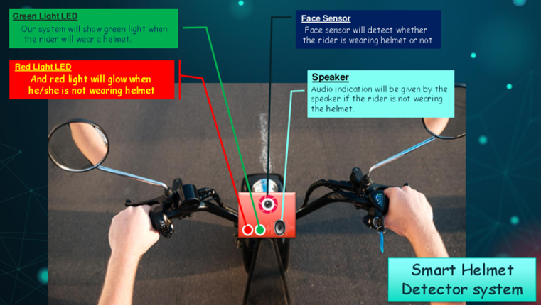
Drive link of all year activity record | https://drive.google.com/drive/folders/1t_YZTRuFJ8xhiM6adSgwFbMt_JoSM166?usp=sharing  http://moodle.mitaoe.ac.in/mod/assign/view.php?id=21599
Peer review & critique | https://forms.gle/TXTtW1hFwiP9hUEV7
Course Website Link | https://sites.google.com/mech.mitaoe.ac.in/mechanicalprototype/home
You tube Link | https://www.youtube.com/watch?v=8eKexypRO30&t=2s  https://www.youtube.com/channel/UCZ_P6fRha2zczClV5jg7oeA
Other LMS Portal Link | http://moodle.mitaoe.ac.in/course/view.php?id=1888  http://moodle.mitaoe.ac.in/course/view.php?id=1159

Course Name / Class / A. Year | Manufacturing Technology / SY BTech / 2018-19, 2019-20, 2020-21 (Term II)
Faculty members involved | A M Kolhe, A.S Chandore
Pedagogical Methods | Method:  Topic Presentation on Cutting Tool Materials.  Description:  1. The concept/topic to each group is allocated and discussed in the class.  2. Students are instructed to refer one recent paper (IEEE, Elsevier, Science direct, Taylor series etc.) related to research work been  carried out in your allocated topic  3. Then students are divided into groups.  4. Students will share (discuss) their understanding of the topic with each other.  5. Finally Students will prepare and explain the same through presentation based on the guidelines given  Benefit to Students:  Exposure to the current work carried out in the given topic as they were supposed to identify the recent research paper relevant to the  topic  Able to understand the analysis of various harvesting as they referred to the research paper.  Provides you an opportunity to learn in detailed about a core subject which is a part of curriculum and develop effective presentation  skills.
Description of the activity | It is require to analyze and evaluate information, synthesis, ideas and creatively demonstrate your understanding of a topic or the findings  of your research. Presenting a research paper develops to bring students out of stage fear and also improve their communication skills.  The activity was Collaborative where a group of three students have to identify the research paper for the topic allocated to them and  present them through a presentation. To assess students learning from these videos, students have to attempt some questions in the lecture  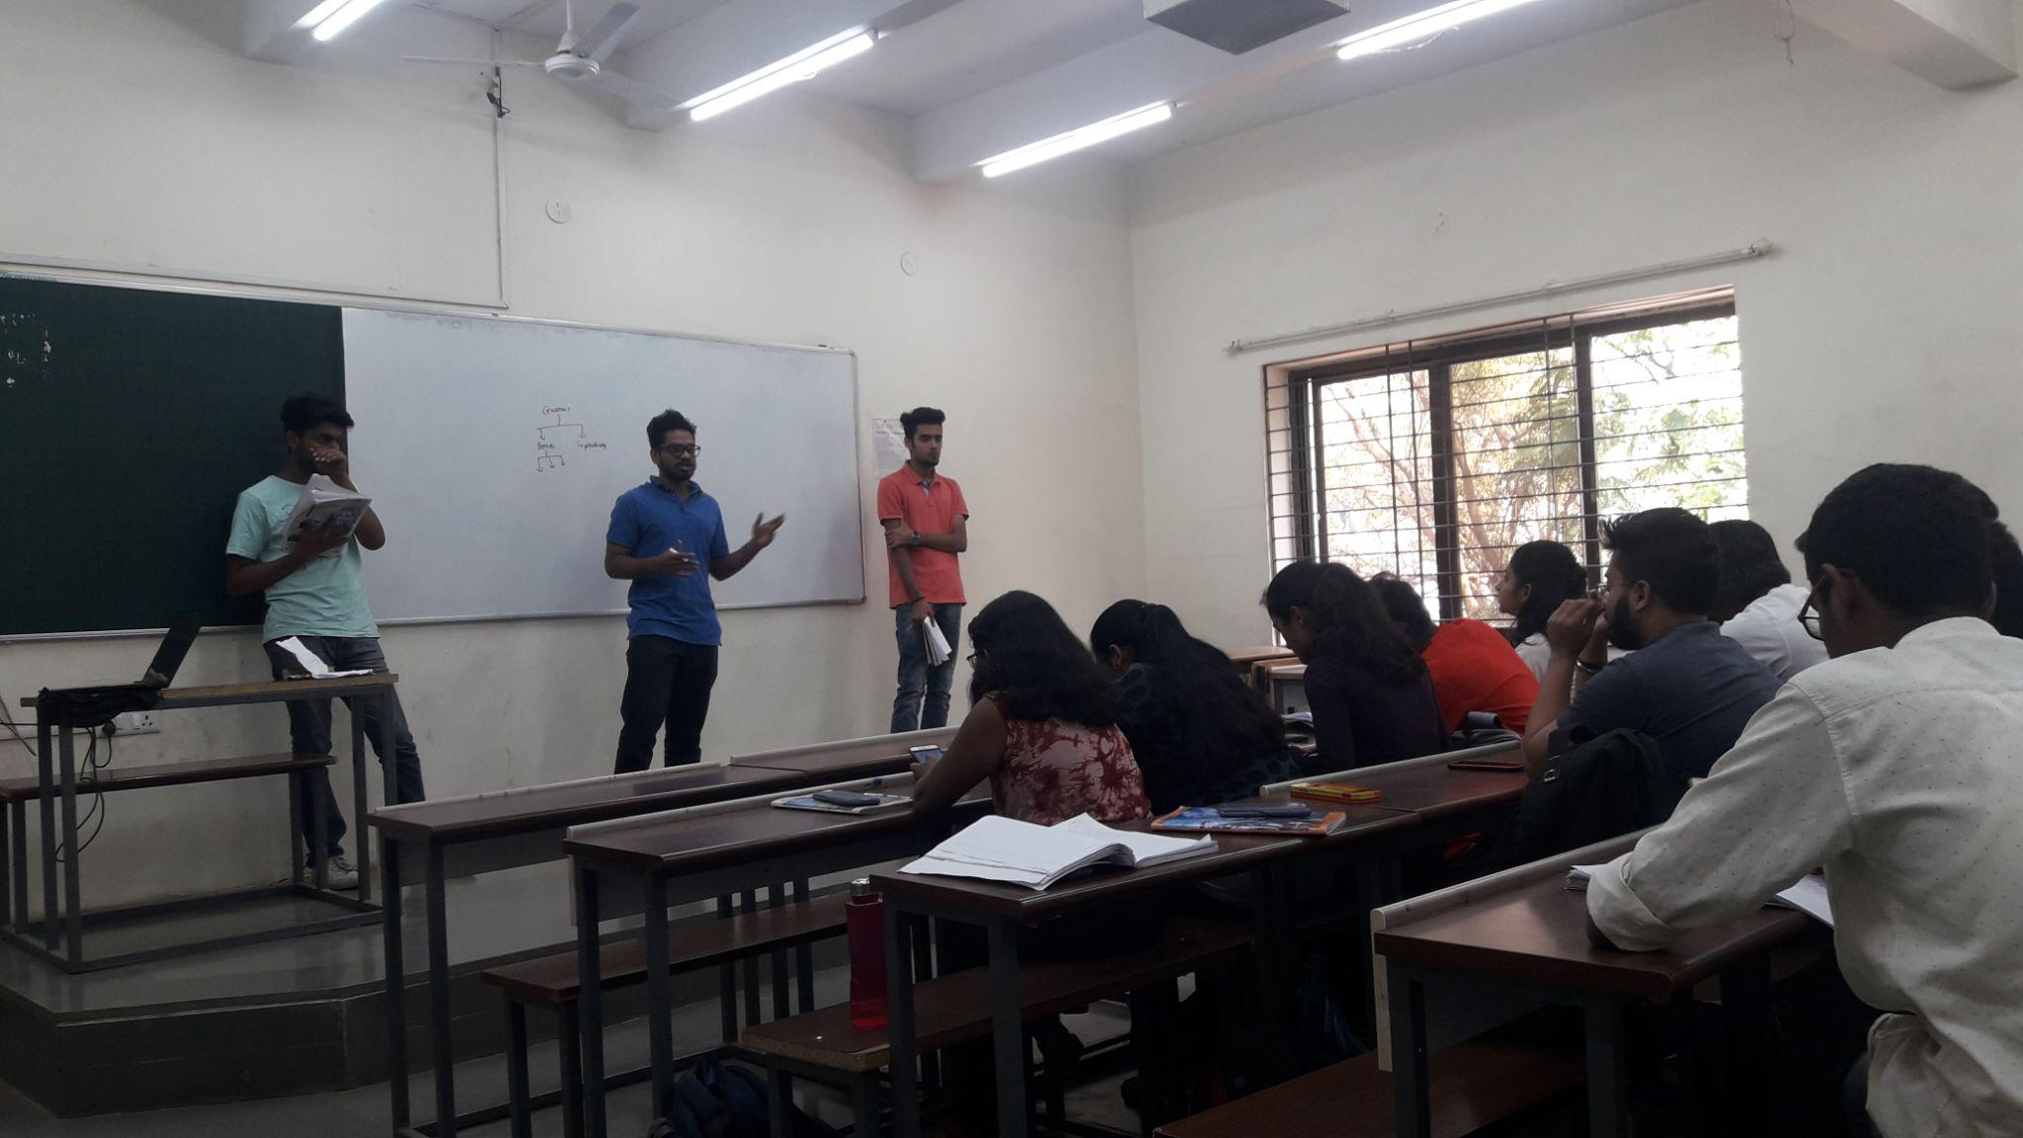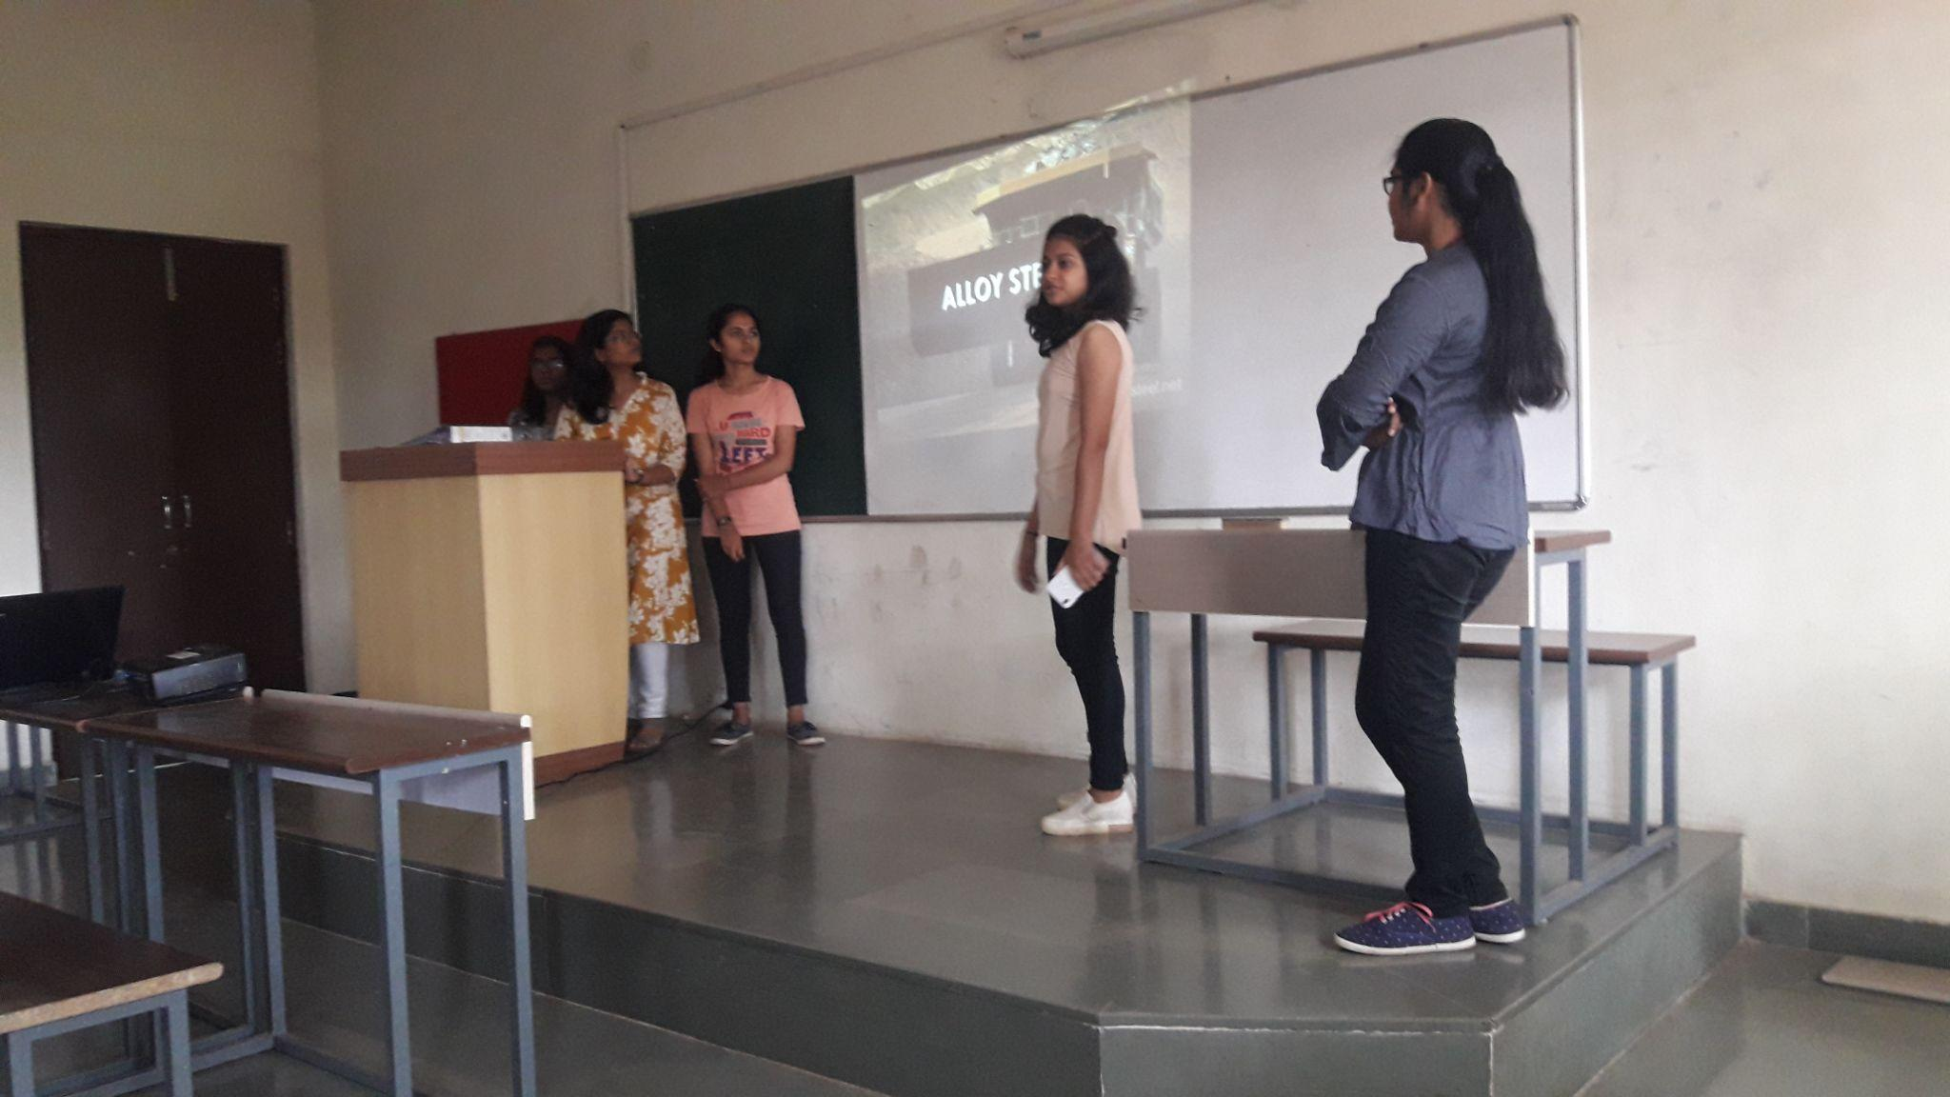

Drive link of activity record
Peer review & critique
Course Website Link
You tube Link
Other LMS Portal Link | http://moodle.mitaoe.ac.in/enrol/index.php?id=326

Course Name /  Class / Year | Industrial Measurements & Control (SY) 2021-22
Faculty members involved | Dr. Prafulla Hatte
Pedagogical Methods | Activities of hands-on practice:  - Activities are conducted based on the hands on practice by the students on measurements.  - Real life cases are given to the students for providing detailed solutions.  - Students are allowed to work individually and in groups. Assessment is done for individuals and in groups.  Benefits:  - Exposure to work individually and in group  - Case study solution with different technical angles such as, Engineering Drawing, numerical solutions, industrial application perspective etc.
Description of the activity
Course Website Link
You tube Link
Other LMS Portal Link | http://moodle.mitaoe.ac.in/mod/assign/view.php?id=29881

Course Name / Class / Year | Quality Management TY 2021-22
Faculty members involved | Dr. Prafulla Hatte
Pedagogical Methods | Method:  The students are asked to work individually for implementation of 5S principles at their home. Grading was done for this activity.  Benefits to the students:  - Real life exposure of 5S principles  - Challenges observation for implementation  - Involvement of the family members during learning  - Skills development for report writing
Description of the activity | Students were explained the concept of 5S. Then the students (individually) were asked to implement any one concept of 5S at their home or any nearby place. The students successfully implemented the principles of 5S at their homes even at remote places in villages. Few students implemented the tasks in farms and nearby garage/workshops also. The students were asked to paste the photos of the activities (before and after the implementation).

Drive link of activity record
Peer review & critique
Course Website Link
Youtube Link
Other LMS Portal Link | http://moodle.mitaoe.ac.in/mod/assign/view.php?id=30771

Course Name /  Class / Year | Design Thinking / FY BTech (All Divisions)
Faculty members involved | Dr. Maya M. Charde, Dr. Abhijit M. Malge, Mrs. Prabha S. Kasliwal, Dr. Mahesh D. Goudar, Dr. Shrikant V. Salve, Ms. Archana M. Mane
Pedagogical Methods | - ARCS Model
Description of the activity | Attention As a co-creator my body language, face expressions and participation with the creators and as an observer plays an important role. Design thinking is a course which is required to experience, means doing by making is the main slogan of the course. While talking with the students I as a co-creator always telling them the concept of reality and the mode of development of the product by giving examples. Ex evolution of mop (real life ex) and also Actual model making competition for my students for checking their multidimensional personality. Means how they are thinking when the task is assigned to them. I am encouraging them that, Creators you have to do something which is useful to the society , who has already directly or indirectly kept on giving you a lot from childhood, now the ball is in your court you got an excellent opportunity to show your talent, your sympathy towards your family, society, nation … This course is a platform for you to express your dream world to convert into reality.  Relevance As technology keeps on developing and changing very fast everybody’s life is becoming very fast and expecting comfort and security from each product, technology, system etc.. So I am explaining to my creators their role to satisfy and give the best solution to the customer. I am telling them the variety of customers for whom they have to work. High class, middle class and low class. The solution to different classes of customer will be different. They have to think about the customer as it is their own problem. Correlation of the course with other courses: This course gives the students actual problem solving skills for any kind of problem. It’s now becoming easy for them to know how to do their B Tech project work, Mini Project etc. The direction is clear to them. The way of solving the customer problem or innovating some product, they were already gone through the market survey, mind mapping, brainstorming and iterating the existing solution for the best one. How to bridge the gap…etc  Confidence Students are also come up with ideas which they felt that it’s difficult for them to do it in reality but as they are starting their project I am guiding them what to do and off course after what action and its really shocking for me that they are able to divide their whole problem into no of steps so it is becomes easy for them to do the activity one by one. To build the confidence among themselves I am giving them AEIOU, empathy , Product life cycle sheets to note down the every moment they spend for their work.(Activity, Environment, Interaction, Object and User) They are really feeling that they are towards the goal of giving the solution to the customer which builds the confidence among them.  Satisfaction First the creators are thinking that they feel something challenging and at last they are able to do that so it’s really great. Students are on the verge of developing good working models and of course innovative. I am confident that I and my creators will definitely be satisfied through the solutions that they are giving to the customer because they are putting their whole efforts for a better solution. Their overall personality is really changing through this course which I feel is the biggest achievement for them.

Drive link of activity record
Peer review & critique
Course Website Link
Youtube Link
Other LMS Link

Course Name / Class / Year
Faculty members involved
Pedagogical Methods
Description of the activity

Drive link of activity record
Peer review & critique

Course Name / Class / Year | ENGINEERING GRAPHICS/ FY BTech (All Divisions)
Faculty members involved | Mr. D. B. Panchal, Ms. N. B. Chaudhari/Ms. R. K. Shastri/Mr. R. K. Patil
Pedagogical Methods | - Model Making activity for Development of lateral surfaces  Benefits to the students:  - Reading the question and interpreting the solution of lateral surfaces  - Handling of tools like drafter for modeling, scissors for cutting the paper, french curve for drawing smooth curves, etc.  - Correlate the products made of sheet metal from industries.
Description of the activity | - Every student allocated a description of solid which is cut by a cutting plane with certain conditions. Students need to read, interpret and draw the development of the lateral surface of the solid as per the conditions given in the question. Then a photo tobe taken as a part of submission. Same solution will be cut using scissors and glue at the ends to make a solid model. Close the model using top and bottom surface drawing on the paper. Auxiliary view concept is used to draw the true shape of the cutting area. And it will be glued to the main solid.  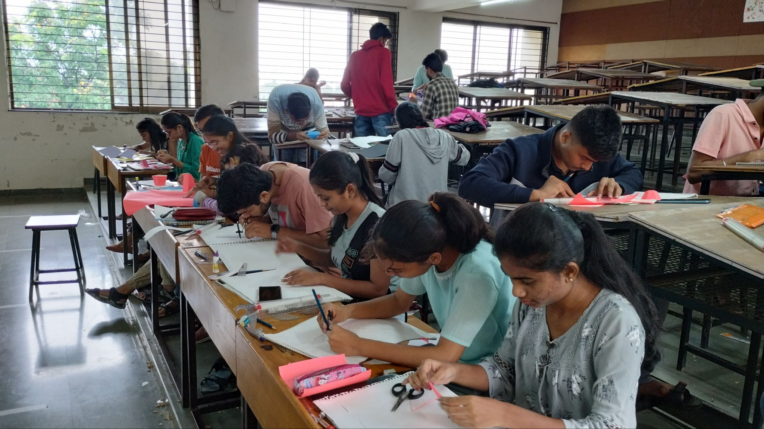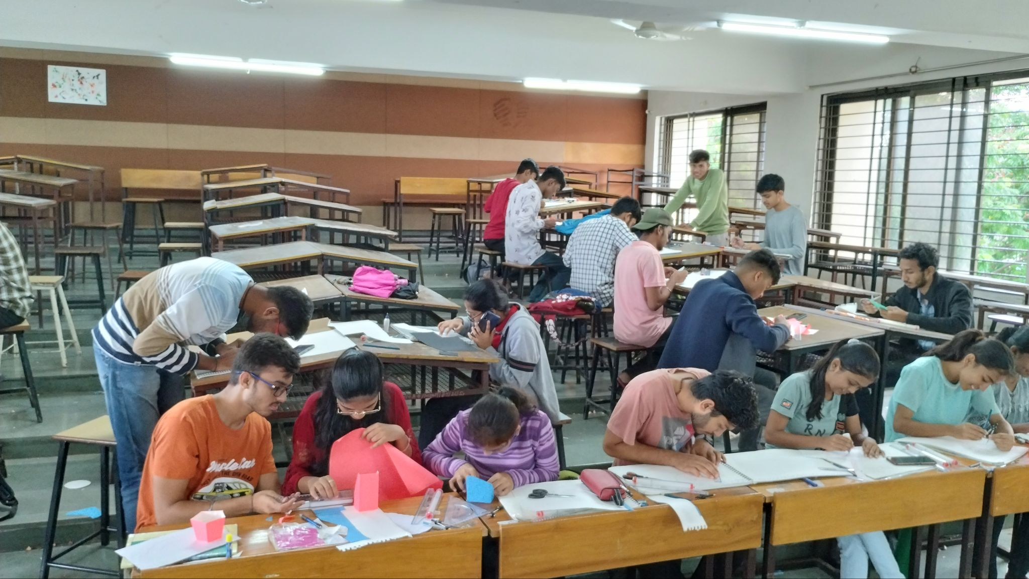
Drive link of activity record | https://drive.google.com/drive/folders/1VmoNOO2ov48xcTuslKiK181ftktnX1o0?usp=sharing
Course Website Link | https://wordpress.com/view/egrmitaoe.wordpress.com
Course YouTube Link | https://www.youtube.com/channel/UC1ZfijRZQmRpoJ3sBLjIjxw

Course Name / Class / Year | Heat Transfer /TY/2021-22
Faculty members involved | Rahul Ashok Patil
Pedagogical Methods | Method: JigSaw Activity ( Active Group Learning Method)  Description:  In Classroom Activity to learn Self Study topics  Benefit to Students:  - Learn from each other a few concepts which they have to do as Self Study as prescribed in Course Curriculum  - Due to this activity student thinking, understanding, interaction and communication skills are improved.
Description of the activity | Steps for Implementing JIGSAW  STEP-1  1. Divide the students into 4-person jigsaw groups or Home group (The groups with  different gender, and ability). Depute the leader of a group.  STEP-2  Divide the Task into 4 segments.  Task selected for JIGSAW activity:  “Natural Convection Heat Transfer ”.  Division of Task:  Segment 1: Discuss the Mechanism of Natural Convection  Segment 2: Dimensionless Number in Natural Convection and Correlation  Segment 3: Discuss the difference between boiling and evaporation, Mechanism of  Condensation  Segment 4: Type of Boiling and Condensation and The Boling Curve for Water at 1 atm  Tell each student to learn one segment. Make sure students have direct access only to their own segment. Give students 30 Minutes to read over their segment and understand it.  STEP-3  Form “Expert Groups” by having one student from each jigsaw group join other students assigned to the same segment. Give students in these expert groups time to discuss the main points and also give time to find what is best possible way to do the segment task of their  segment and to rehearse the presentations they will make to their jigsaw group.In this step student will come up with a strategy, methodology which individual will use in performing his or her task with the help of software used for performing the task when he or she  will return to his or her Home group.  STEP-4  Bring the students back into their jigsaw groups. Ask each student to present her or his segment to the group. If the task is sequential and each next segment is dependent on the previous segment, then it is better to start the presentation from segment-1 and followed by 2, 3 and 4. And then, ask them to start their task from segment-1 to segment-4 as per decided strategy in  Expert Groups.  STEP-5  Move around, observing the process. If any group is having difficulty, make an appropriate intervention. Eventually, it's best for the group leader to handle this task.  STEP-6  At the end of the session, give a quiz on the material. Students quickly come to realize that these sessions are not just fun and games but really useful for learning.

 | 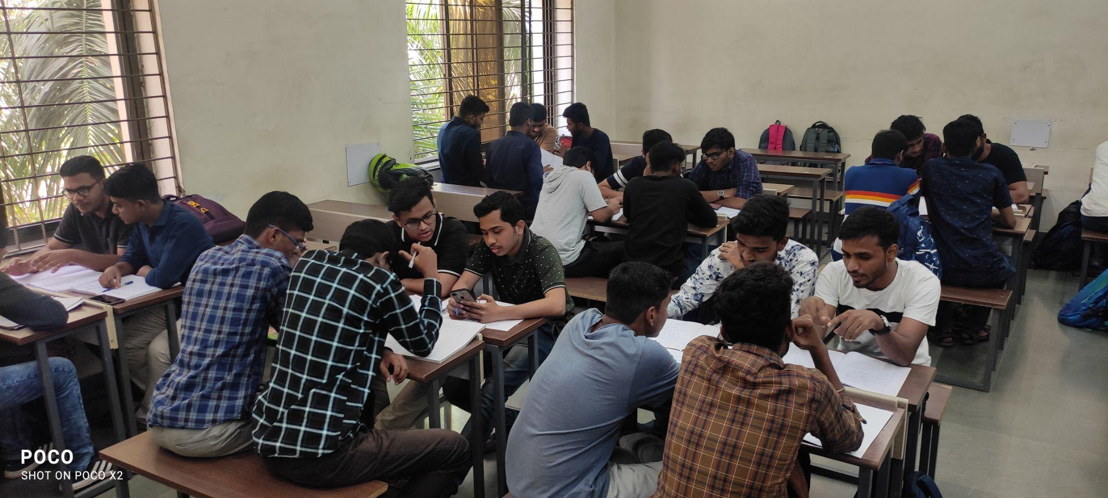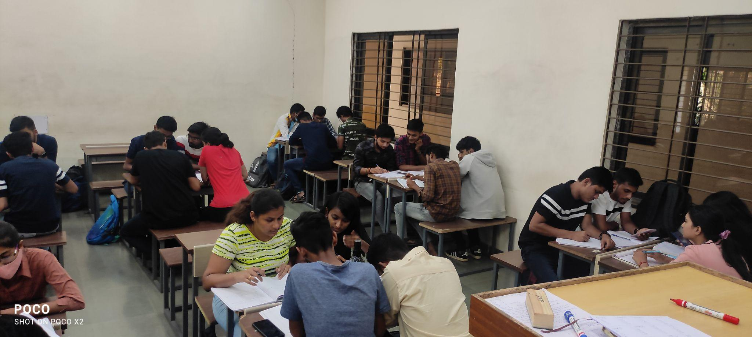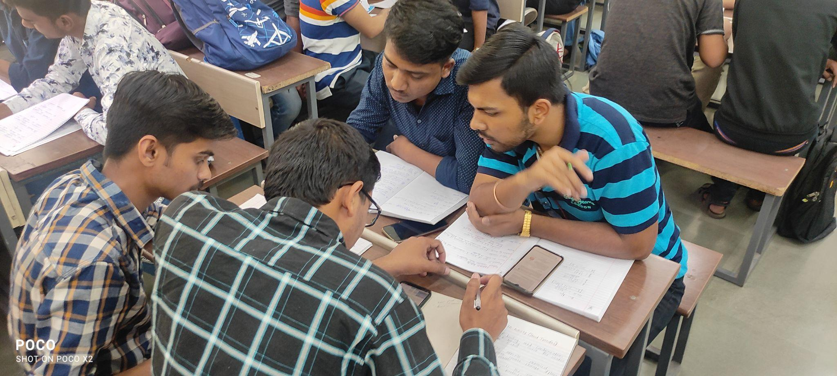
Drive link of activity record | https://drive.google.com/file/d/17UXvdNRG4LUDWFds4N0vBLkpBXci7OfZ/view?usp=sharing
Peer review & critique

Course Name / Class / Year | Turbomachines/TY/2021-22
Faculty members involved | Rahul Ashok Patil / Dr A G Kamble / Prof S B Powar
Pedagogical Methods | Method:  Project Based Learning and the activity is evaluated by the group-wise presentation  Strategy of Conduction  1. All students are divided into a group of 5 students each  2. Each group has allocated a separate project topic  3. Each group has to study the topic thoroughly and make a presentation  4. Each group has to submit the presentation  5. The evaluation of activity is done through the group-wise presentation  6. The marks distributions are individual not in a group  Benefit to Students:  - In this activity, groups are formed as per the student’s responses, so that each group contains a student with different learning capabilities and together they can learn and think to produce an effective output.  - Students are able to analyze the given application specific topic in the area of Turbomachines  - Students are able to list out the requirements based on the analysis  - Due to this activity all students have got hands-on the software like CATIA and ANSYS ,EPANET
Description of the activity | There are three project based Lab activities prescribed in the course curriculum .Any group has to perform any 2 activities.  Activity 1 : Design of Turbine/Pump/Compressor for required application using suitable software tool?  1. Select the Turbine/ Pump/ Compressor for designing.  2. Do the literature review ( minimum 5 Research paper)  3. Identify the steps of Design of Turbomachines Perform the Analytical calculation.( You may prefer Excel/Matlab/Python etc)  4. Model the turbomachine in suitable CAD software.(3D Model)  5. Prepare the report (7-8 Pages) and presentation (5-6 Slides)  Activity 2 : Design of pumping system installation using manufacturers’ catalogue, specific to domestic or industrial application.  1. Select the company catalogue to design pumping system for domestic or industrial application  2. Identify the steps to Design the pumping system  3. Perform the Analytical calculation  4. Use the EPANET software/any other suitable software for designing flow/piping system.  5. Discuss the IOT application to avoid the losses  6. Discuss the characteristic curves for the Pump  7. Prepare the report and presentation

Activity 3 : Design and Analysis of Vanes/Blades of Turbomachines using suitable software.
1. Select the Vanes/Blades of Turbomachines
2. Do the literature review (minimum 5 Research paper). Do the required analytical calculation.
3. Model the Vanes/Blades of Turbomachines in CAD Software /CF Turbo / any other software
4. Perform the Analysis ( Flow/Thermal/Structural/Effect of Vane angle etc.) on Vanes/Blades of Turbomachines
5. Comparative analysis of Analytical and Numerical efficiency.
6. Suggestions for improvement in efficiency/Conclusion
7. Prepare the report and Presentation

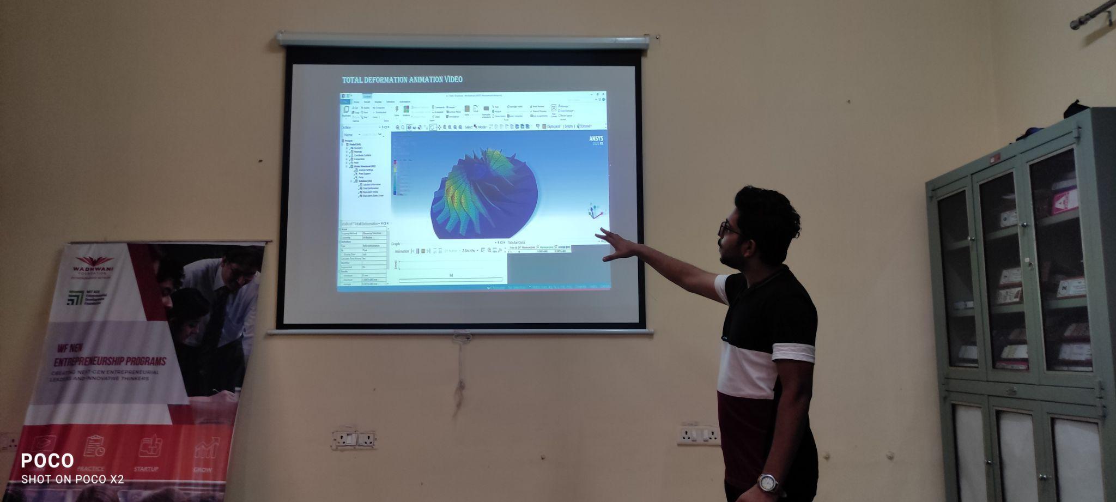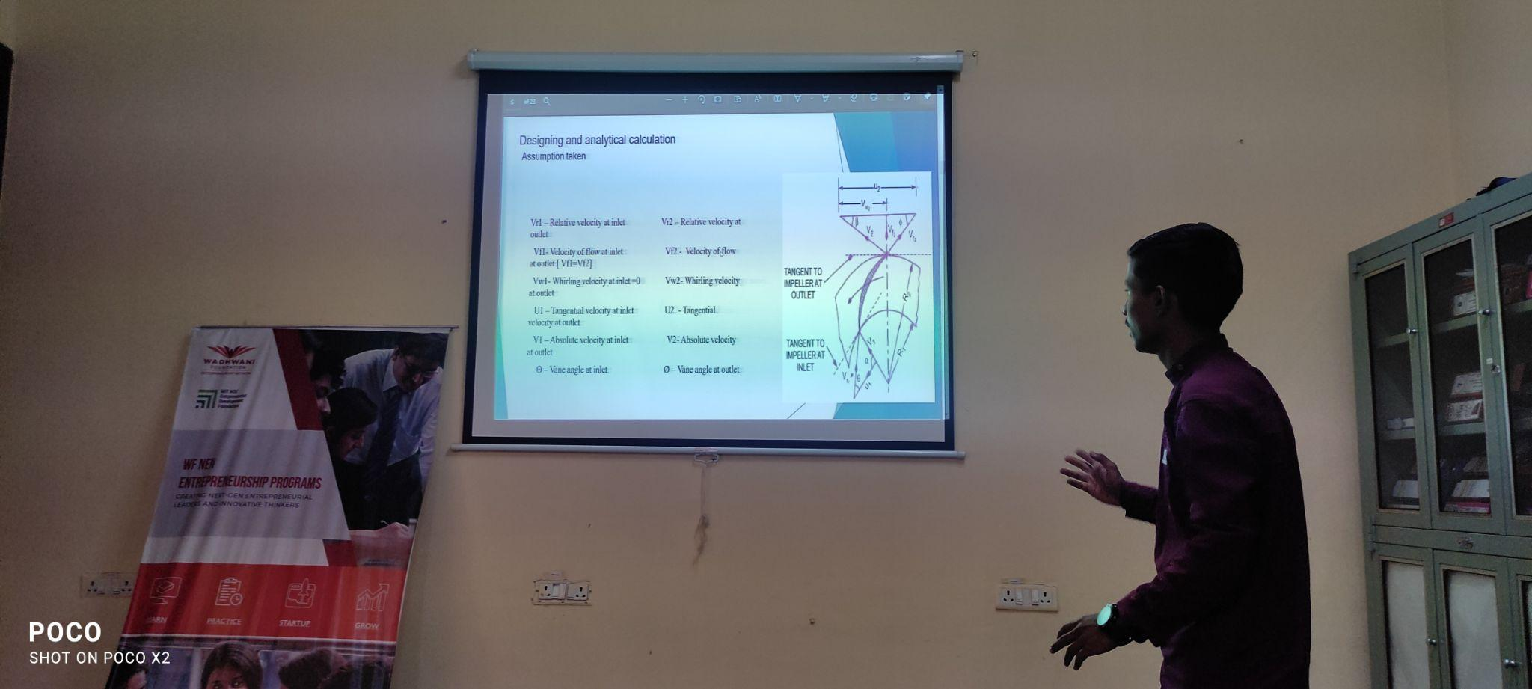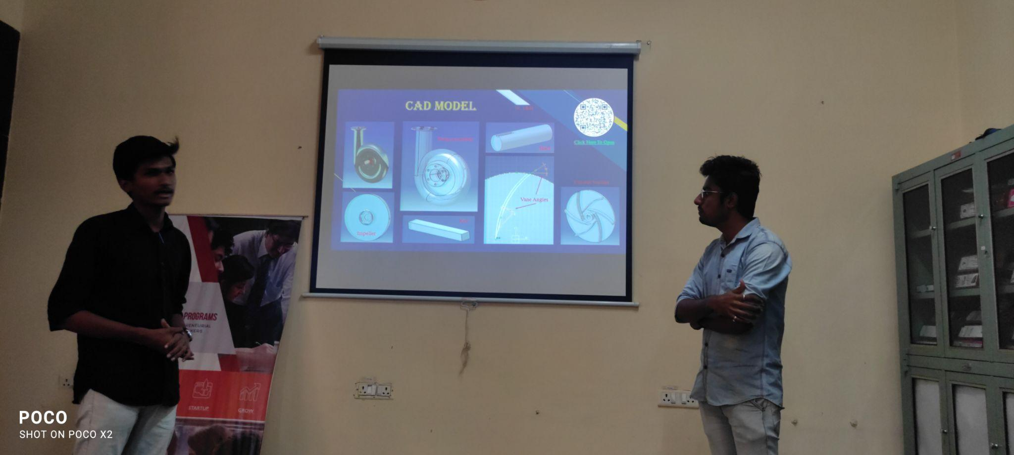

Drive link of activity record | https://drive.google.com/drive/folders/1pcZ16U0qsd0G2FvLitlZmRK6kuJwqOhP?usp=sharing
Peer review & critique

Course Name / Class / Year | Engineering Informatics ME222 (2021-22)
Faculty members involved | Dr. Surendra Barewar
Pedagogical Methods | Activity in the class for applying knowledge to find the KPI in the dashboard  Method:  - Activity are conducted based on the hands on practice by the students on measurements.  - Real life cases are given to the students for providing detailed solutions.  - Students are allowed to work individually and in groups. Assessment is done for individuals and in groups
Description of the activity
Drive link of activity record | http://moodle.mitaoe.ac.in/mod/assign/view.php?id=29881
Peer review & critique

Course Name / Class / Year | Hydraulics & Pneumatics ME 343 T , 2021 , Ty Btech A Div
Faculty members involved | Rahul Kumar Patil
Pedagogical Methods | Method: Project based learning  Benefit to Students:  - Learned to design hydraulic systems for gamification. (Build your Game activity)  - Simulate the Circuit in fluid sim software for better understanding  - Design a Hydraulic Circuit considering any logic operation  - Simulation of pneumatic circuit using Fluid sim
Description of the activity | Build Your Game:  - It is graded activity in which u need to use a cardboard generate a way to reach starting to ending point using barriers, Then mount this frame to the 20 ml Syringe such that they remain flat at all support, Shape should be as per your liking , hexagon , pentagon, Rhombus, circle Parallelogram, etc use at least 4 supports . I am attaching a Dummy Model for your understanding. We will arrange a competition for the same.  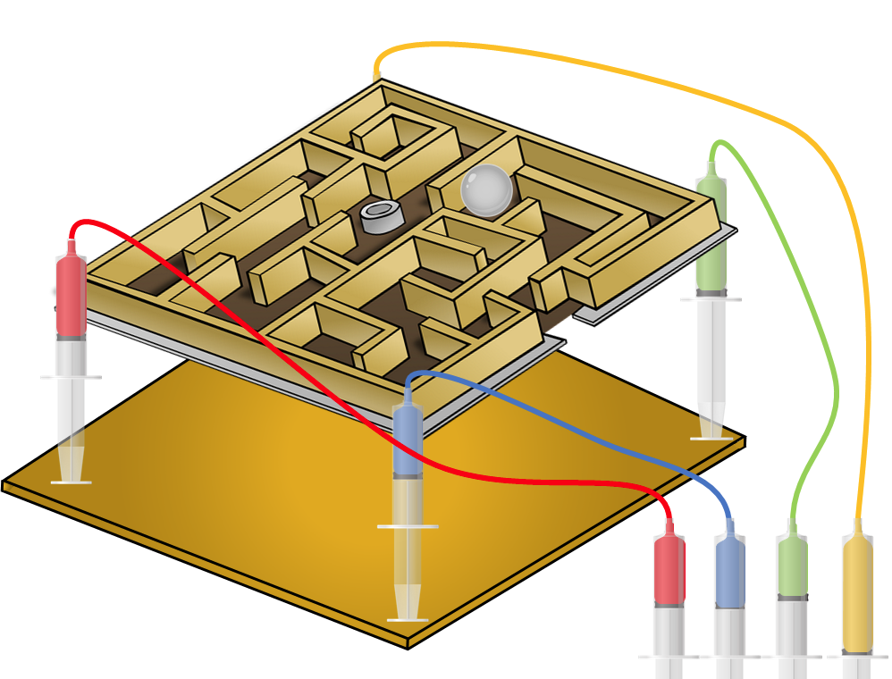  Just for explanation .  Design of Circuit :  - Strictly follow the procedure. Don't send Copy paste material .  - Use Fluid Sim software Simulation to draw the circuit. (available at get into PC.)  - Each question carries 10 marks ,you need to prepare a report in word format, upload it with a plagiarism report . ( its mandatory to submit both )  - Make a small video explaining circuit simulation using any screen recording tool. Upload the link of video  - Your Report should not have any images other than circuit drawing of FLUIDSIM  - No extra time will be allotted , nor the late submitter will be entertained.

Drive link of activity record | Build ur Game : https://drive.google.com/drive/folders/1Gm140i-q8DS2n7gRXgxsQ15voYteF2mF?usp=sharing  Simulation based activity :  Design of Hydraulic Circuit :  Video link: https://drive.google.com/file/d/18mgSGx6eMgFM4qzrLNJ5ESUVZbyG-qwR/view?usp=sharing  File link  https://drive.google.com/file/d/1k4v5G4anUBmzN7mYVHC7MzAcnT50XGCb/view?usp=sharing  plagarism Report link  https://drive.google.com/file/d/1nqy1dZ4Q1QyWdBey8-n6xPWhL_QlmRvc/view?usp=sharing
Peer review & critique | Students were given White paper from Eaton , Allen Bradley so that we may get aware of the new technologies in Hydraulic & pneumatics and Simulation of the hydraulic circuit where done to understand the working of hydraulic circuit. with max pressure ranges.
Moodle Link : | http://moodle.mitaoe.ac.in/course/view.php?id=845

Course Name / Class / Year | Noise Vibration and Harshness ME431/ Final Year BTech
Faculty members involved | Amol J. Asalekar, Rupesh S. Jadhav, Y L Maske, A. G. Kamble
Pedagogical Methods | Method:  Presentation Activity  Benefit to students:  - Revision on topics for each student in the class  - Revision on topics for absent student for that specific topic  - Understanding of the student for that topic
Description of the activity | This activity is taken in class for final year students, before 1 week of the activity conduction topics are allotted for each student. 1 week was given for the preparation of that specific topic. Students have to prepare ppt for the same. Students have presented the same topic in class. This activity is conducted for 10 Marks (graded activity). After the presentation students have to upload their ppt on moodle.  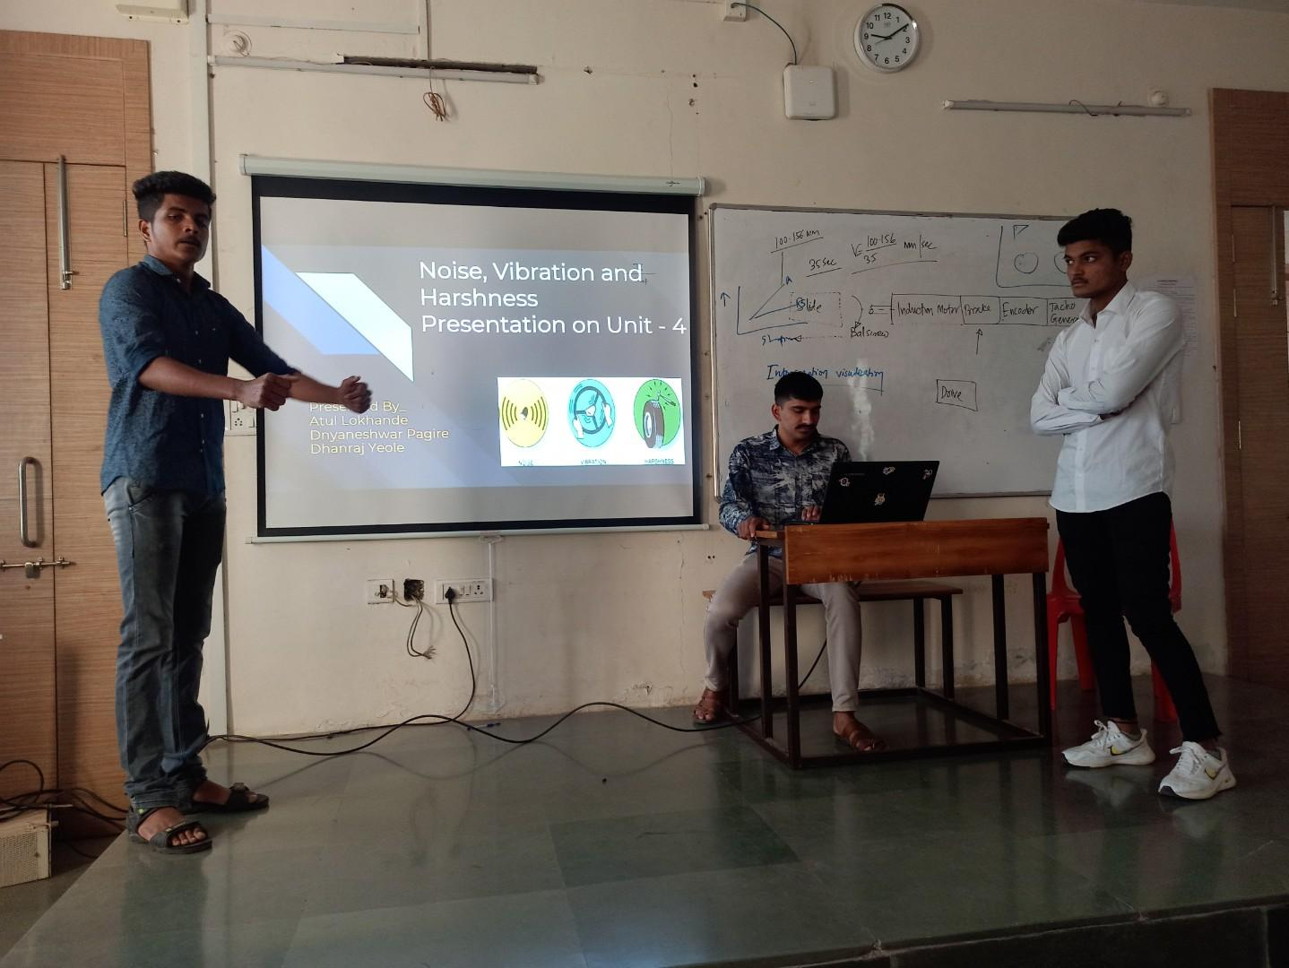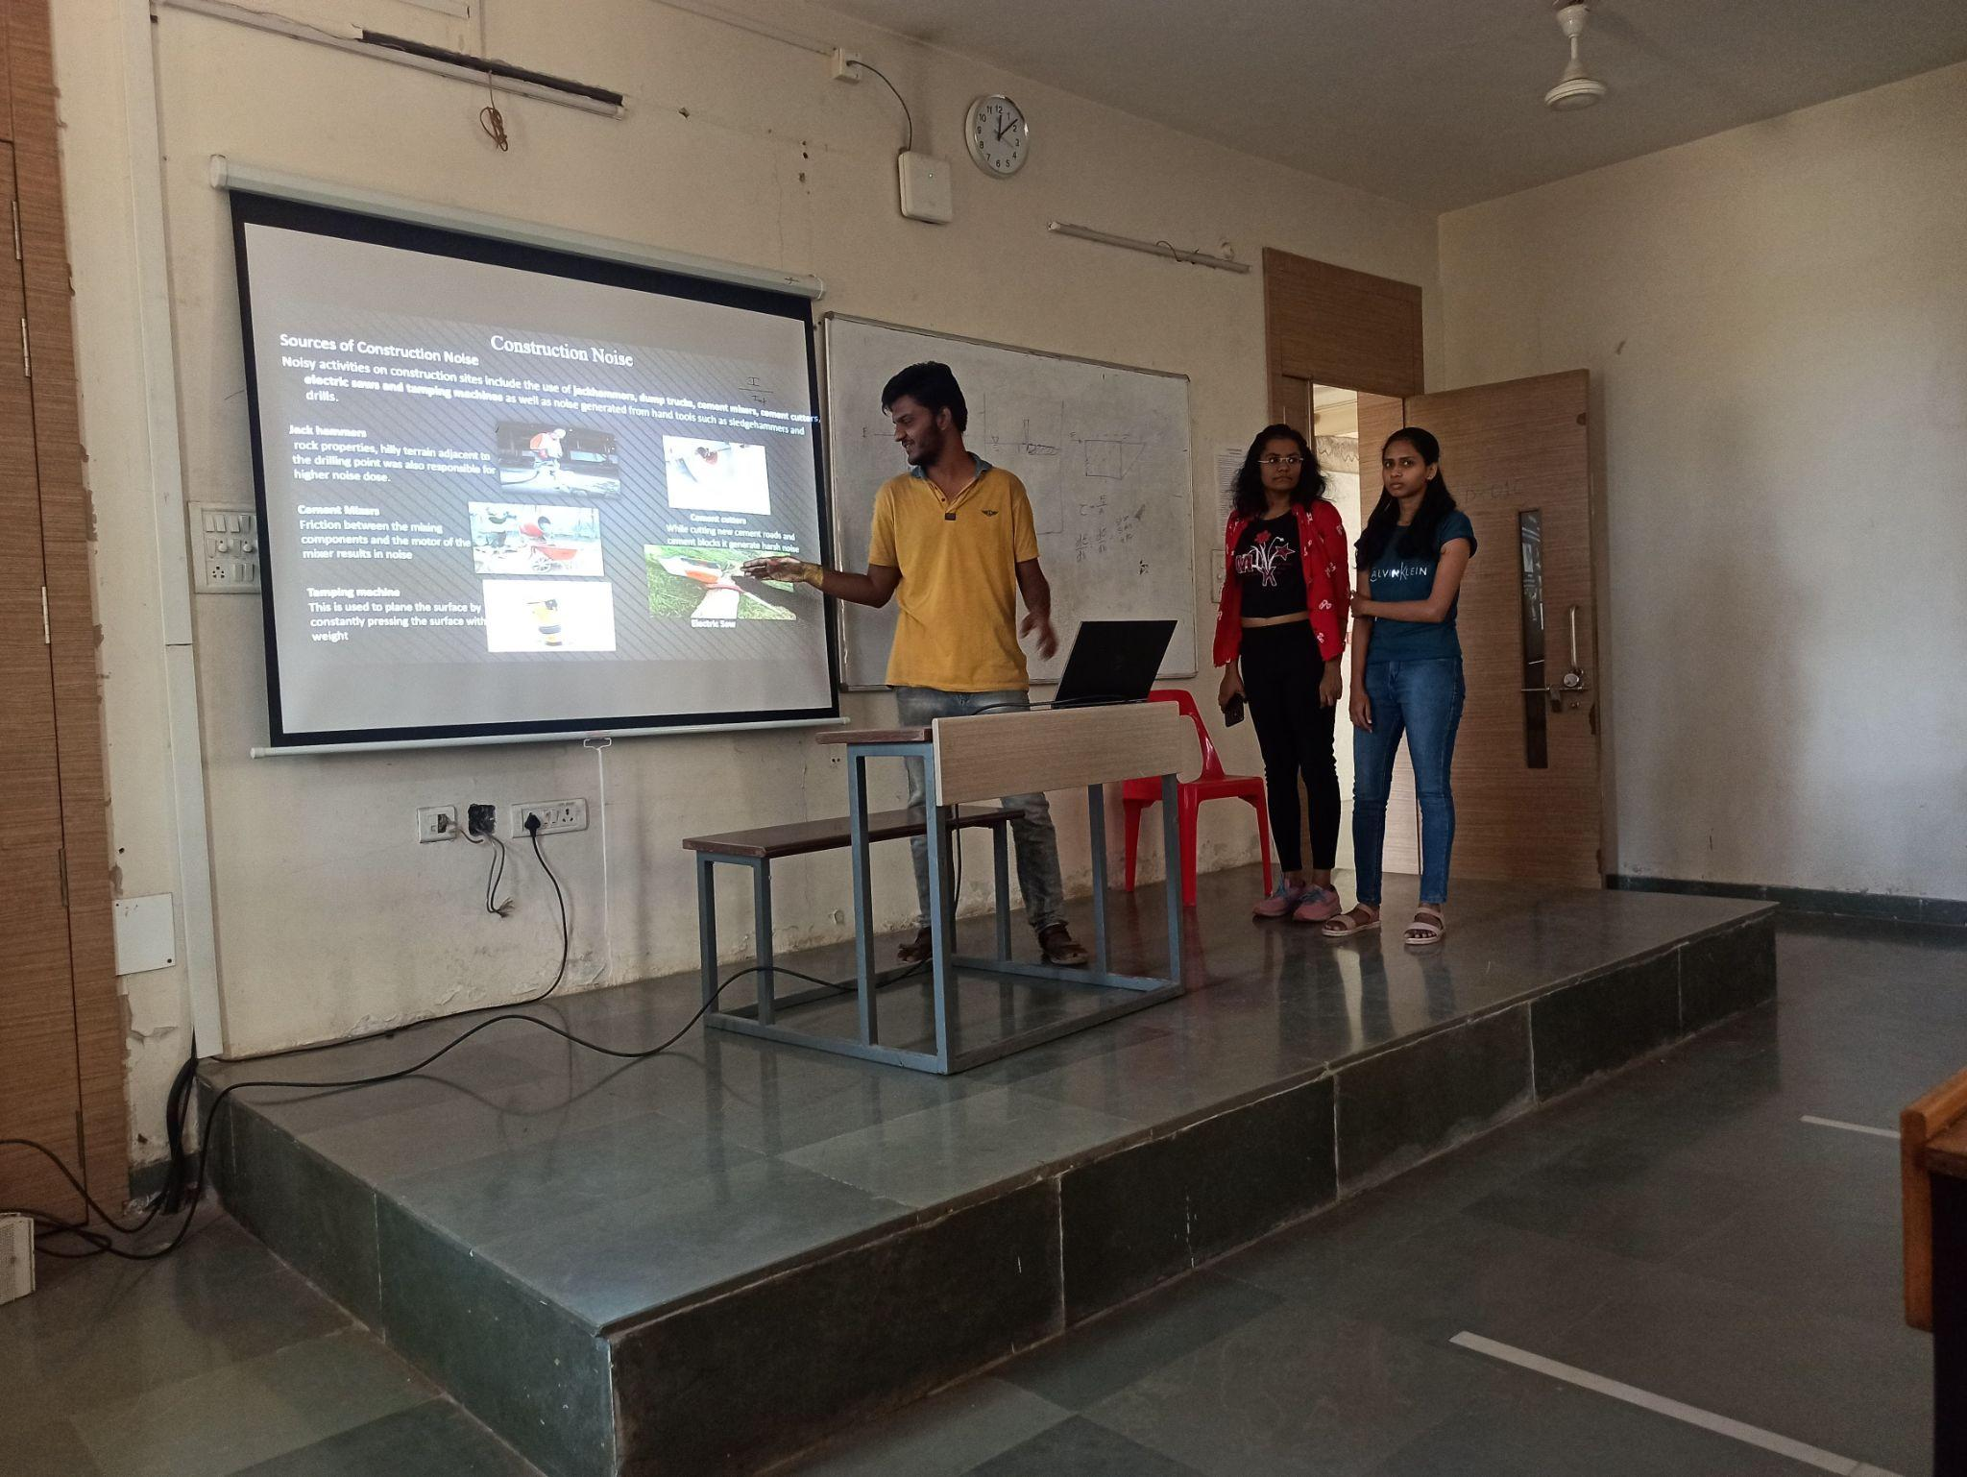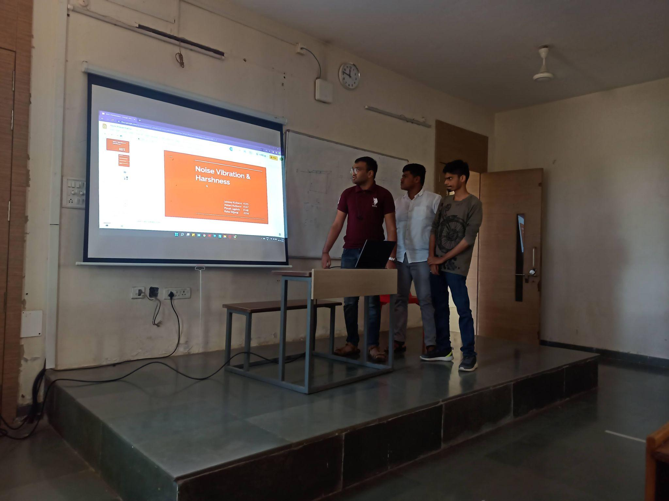

Drive link of activity record | http://moodle.mitaoe.ac.in/mod/assign/view.php?id=35741&action=grading
Course website link | https://asalekar.wordpress.com/courses/
Peer review & critique

Course Name / Class / Year | Strength of Materials ME231/ SYBTECH
Faculty members involved | Amol J. Asalekar, Dr. Maya Charde, V N Deshmukh
Pedagogical Methods | Method: Virtual Lab Conduction  Benefit to Students:  Students can visualize the experiments in Virtual mode in pandemic situations.  Absents students can study these virtual mode experiments at any time anywhere.  Videos and simulation videos are very clear for understanding of the students.

Description of the activity | In lab sessions of Strength of material virtual labs are taken from various platforms made by IIT and NIT institutes. Youtube videos are also shown for various experiments.
Drive link of activity record | Website for various labs: https://sm-nitk.vlabs.ac.in/List%20of%20experiments.html
Peer review & critique

Course Name / Class / Year | Thermal Engineering (ME232) Second Year B.Tech
Faculty members involved | Dr. Mahesh P. Joshi, Dr. N. B. Totla, Dr. S.D. Barewar
Pedagogical Methods | Method: JIGSAW ACTIVITY  Description:  Course Outcomes: Evaluate performance of various IC engine systems.  TOPIC:- Comparison of different engine systems:  1] Engine lubrication system  2] Engine cooling system  3] Engine pollution & its controlling methods  4] Turbocharger system  Benefit to Students:  - 1] Improve self learning, listening and communication skills.  - 2] Enhance leadership and team work qualities.  - 3] Understand time as well as stress management skills.

Description of the activity | How to conduct JIGSAW Activity:--  Step 0] Make sure that all the prerequisites are done successfully.  Step 1] Divide students into 10 person jigsaw home groups. The groups should be diverse in terms of gender and ability.  Step 2] Appoint one student from each home group as the group leader. Initially, this person should be the most mature student in the group who has leadership qualities or volunteer.  Step 3] Assign each student to learn any one segment as per their mutual understanding or under instructor guidelines.  Step 4] Give students time to read over their segment and become familiar with it.  Step 5] Form “expert groups for every segment” by having one student from each jigsaw group join other students assigned to the same segment only. Give students sufficient time to discuss their segment and take notes on the same.  Step 6] Bring the allotted segment wise students back into their home jigsaw groups. Ask them to present the important points related to segment into the group. Encourage others in the group to ask questions for clarification, if any.  Step 7] Give sufficient time for the home group to prepare a report on the same, which will be evaluated by the instructor on the basis of rubrics.  Challenges:  1] Occasionally, some particular dominant students preferred to plagiarize the material rather than cooperative learning. Also talk too much or try to control the group or create disruption in the process.  2] Slow thinkers or poor readers will be lagging behind during the activity, which resulted in poor performance of the group.  3] If prerequisites are unsatisfactory then smooth conduction of such activity will become a hurdle.  Rubrics :-  Category Weight 4 3 2 1  Clearly explained technical terms. 30% Stepwise correct solutions have no mathematical errors Few of the steps and solutions have no mathematical errors. Most (Upto 50%) of the steps and solutions have no mathematical errors More of the steps and solutions have mathematical errors  Presentation of Parameters correctly technically 20% Proper Step Wise procedure and accurate classification of parameter Proper stepwise procedure and quite accurate classification of parameters Procedure is difficult to understand and less accurate classification of parameters No Proper Procedure and classification of parameter  Neatness, organization & Completion 15% The work is presented in a neat, clear, organized fashion that is easy to read The work is presented in neat and organized fashion that is usually easy to read. The work is presented in an organized fashion but may be hard to read at times. The work appears sloppy and unorganized.  Diagrammatically explanation. 15% Diagrams are clear and greatly add to the readers understanding of the procedures. Diagrams are clear and easy to understand. Diagrams are somewhat difficult to understand. Diagrams are difficult to understand.  Conclusion 20% Sound (Detailed & clear) logic in conclusion. Minor flaws in logic in conclusion. Major flaws in logic in conclusion. No any logic in conclusion.  Photo Gallery of Events  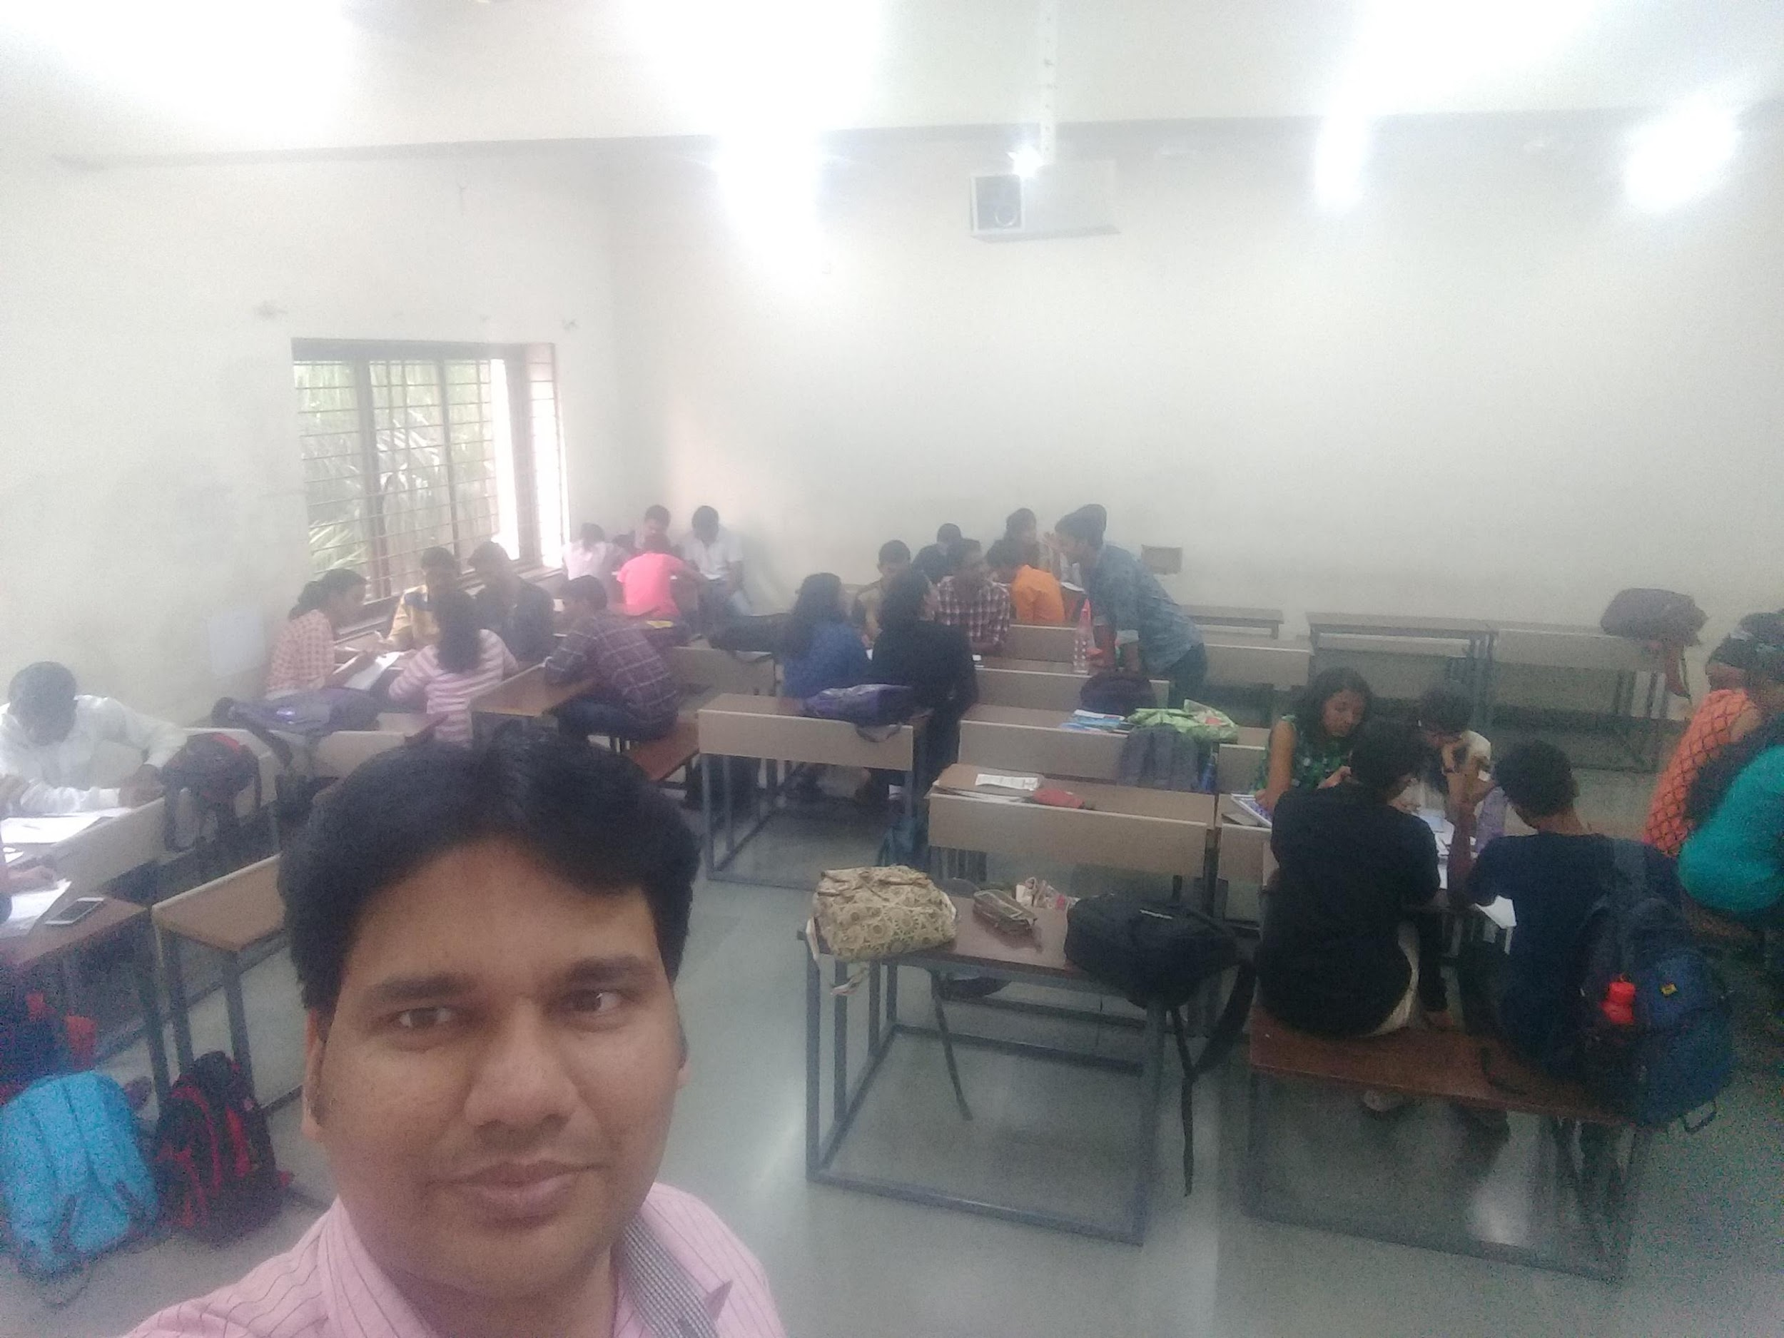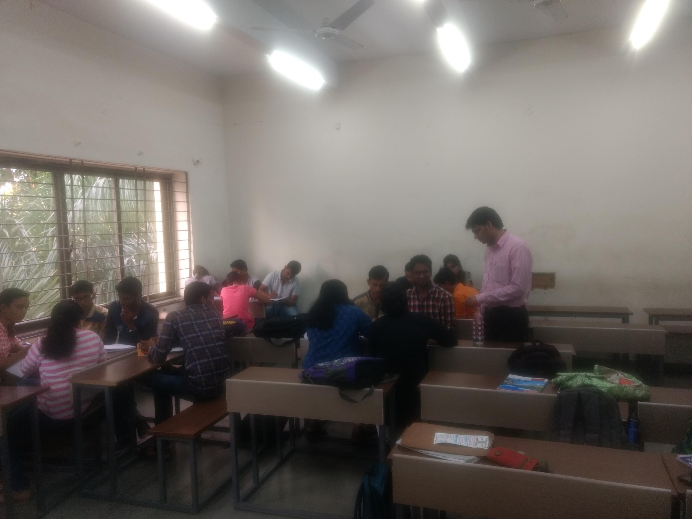
Drive link of activity record | https://docs.google.com/document/d/1a-51PMAmjEXotyllxpd9HW9I6_fU2Ska/edit?usp=sharing&ouid=106602897471438284456&rtpof=true&sd=true
Peer review & critique

Course Name / Class / Year | Thermal Engineering (ME232) Second Year B.Tech
Faculty members involved | Dr. Mahesh P. Joshi, Dr. N. B. Totla, Dr. S.D. Barewar
Pedagogical Methods | Method: Poster Presentation Activity  Description:  To collect technical information regarding importance and applications of recent trends in manufacturing industry through various sources, prepare posters on the same in precise as well as summarized format and finally do a presentation in front of judges.  Benefit to Students:  - 1] Improve self learning, listening and communication skills.  - 2] Enhance leadership and team work qualities.  - 3] Understand time as well as stress management skills.
Description of the activity | Purpose of Activity: To collect technical information regarding importance and applications of recent trends in manufacturing industry through various sources, prepare posters on the same in precise as well as summarized format and finally do a presentation in front of judges.  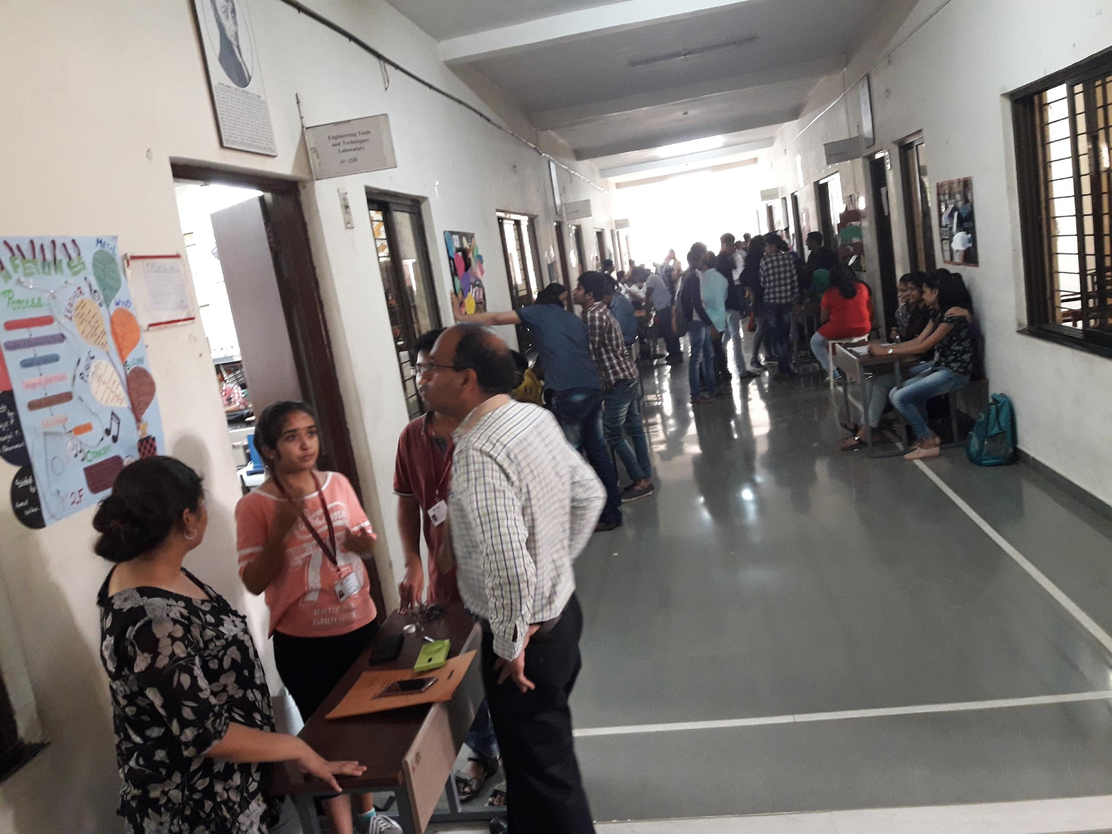  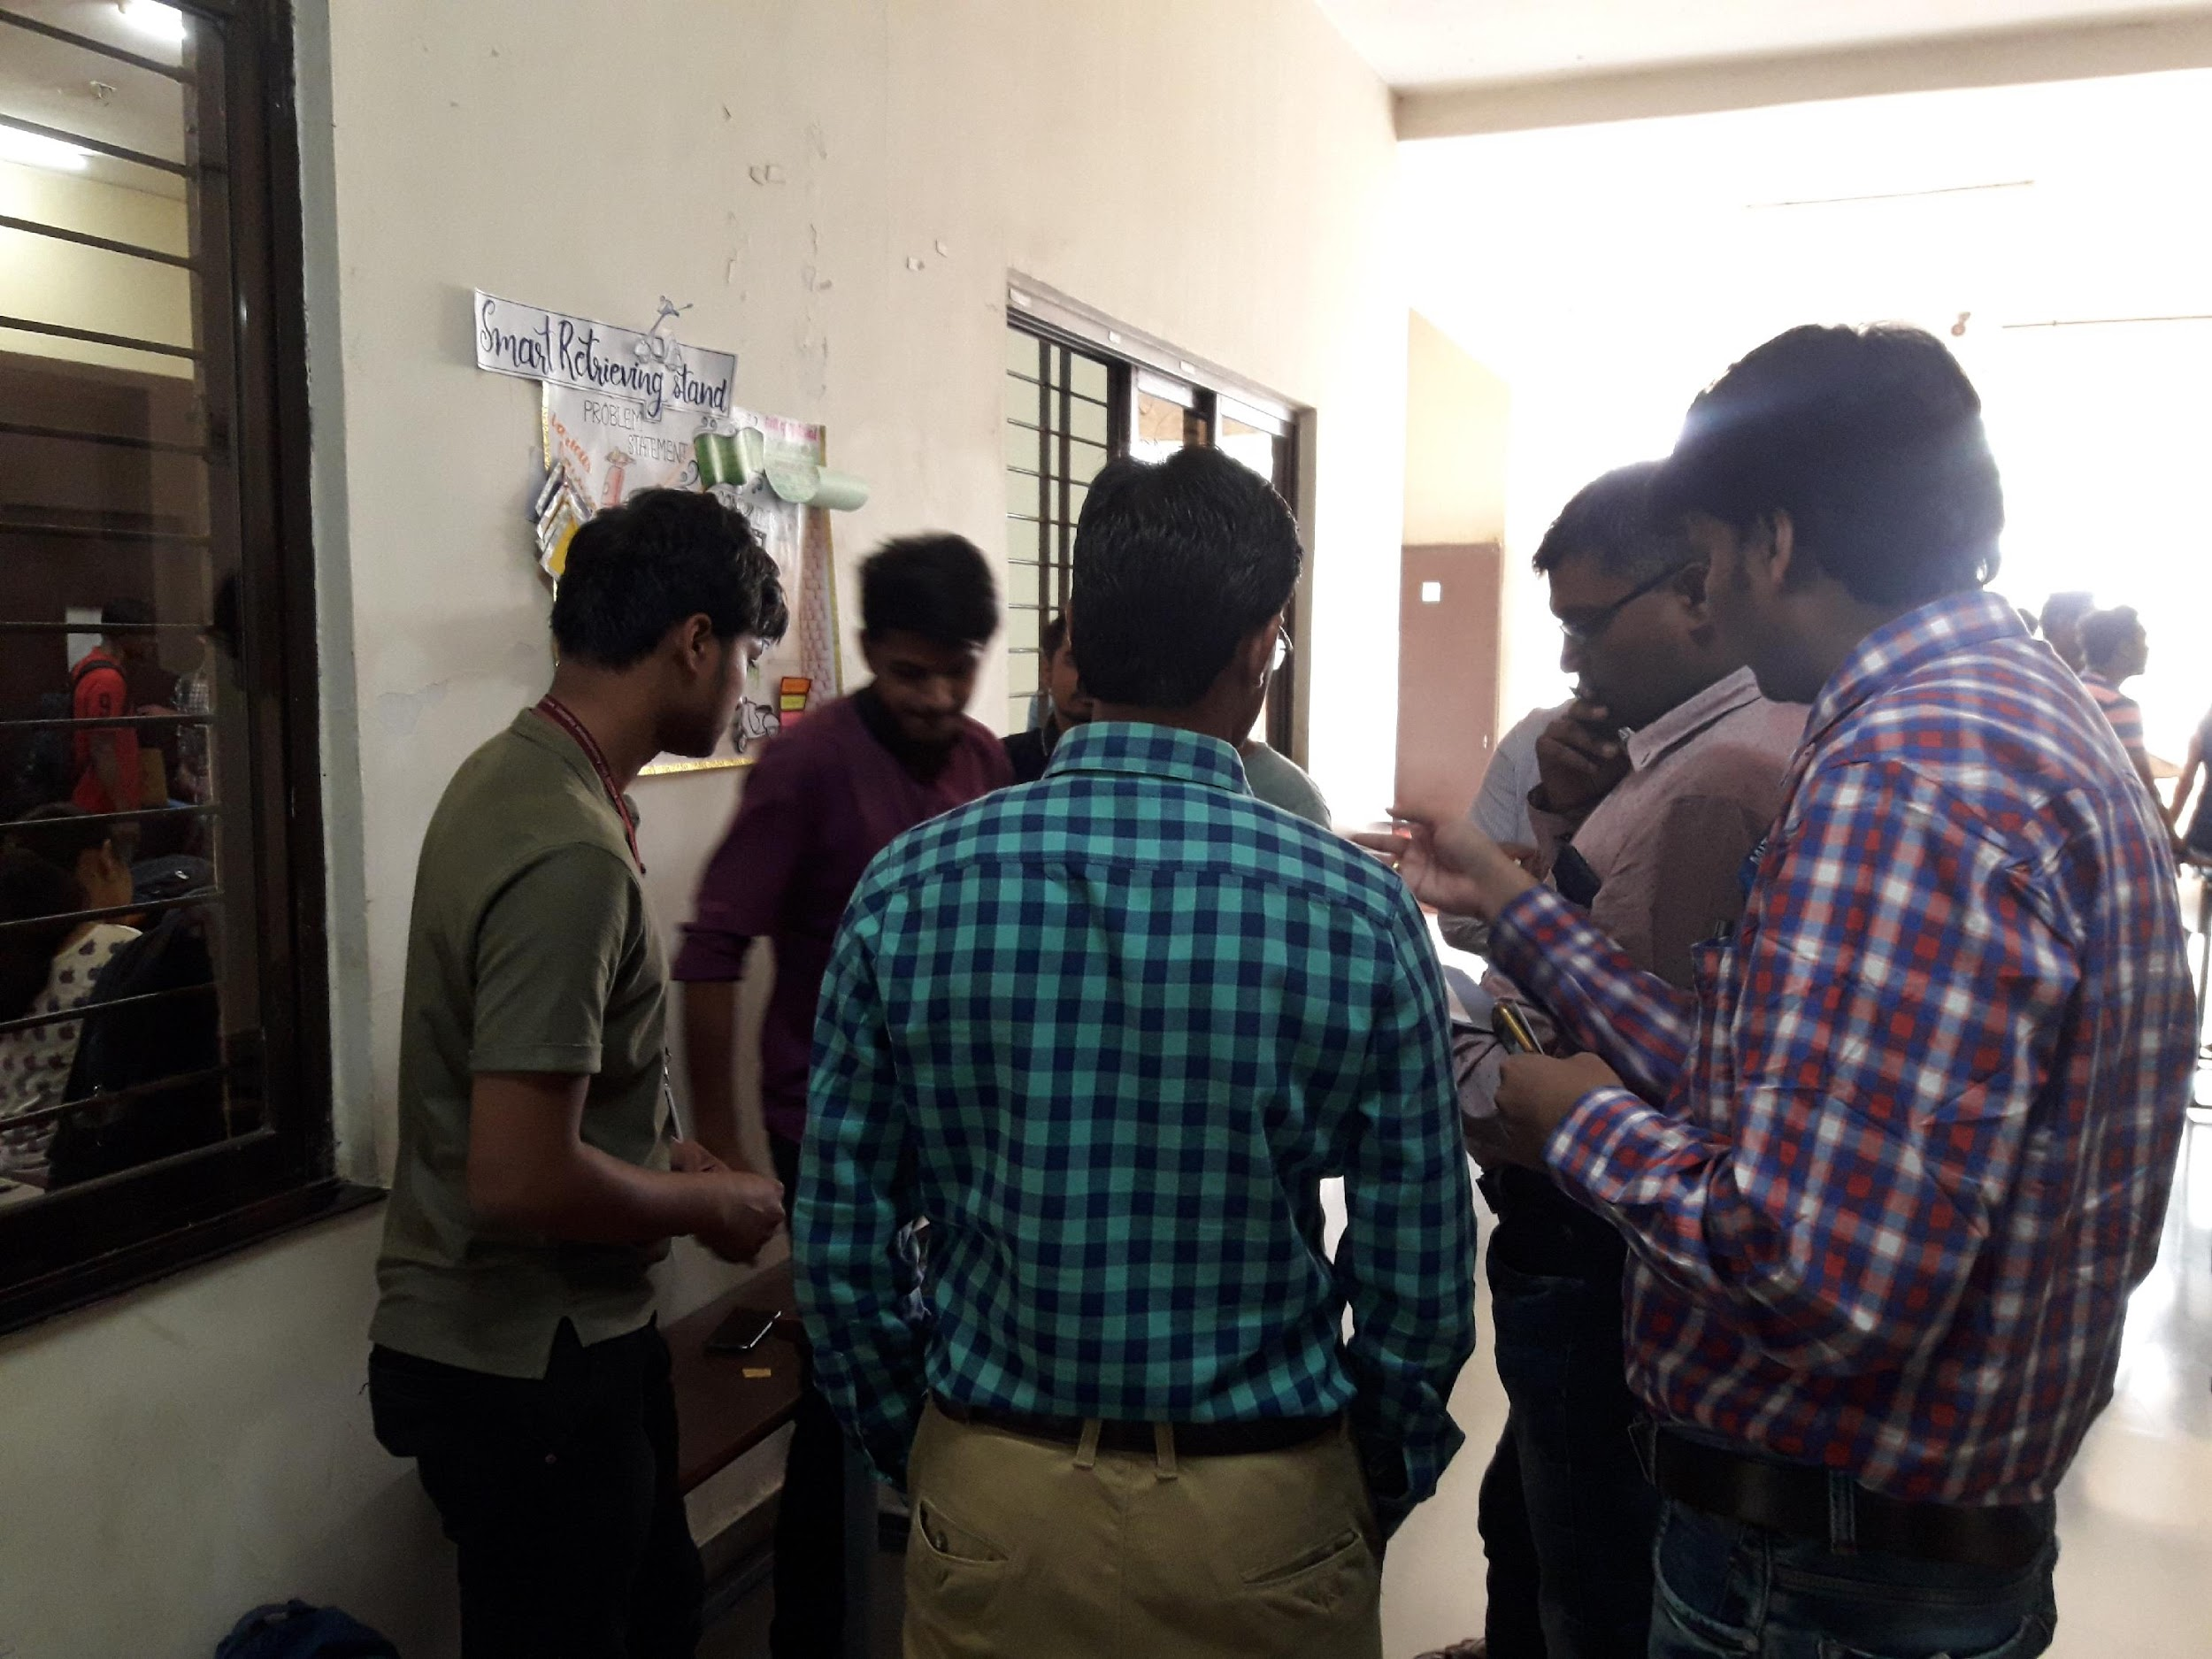

Drive link of activity record | https://docs.google.com/document/d/1k_Y2lWobllqrdTMHyvlRlDxW47L6HIoU/edit?usp=sharing&ouid=106602897471438284456&rtpof=true&sd=true
Peer review & critique

Course Name / Class / Year | Fluid Mechanics/SYBtech/2021-22
Faculty members involved | Mr. Sudesh Powar
Pedagogical Methods | Method: Jig Saw Activity  Objectives:  - · Student should be able to work in a group as a teammate  - · Student should be able to express a technical concept to their group members  - · Student should gather the information, analyse it, try to tell others by their own.  - · Student should try to listen and learn from other student.  - · Student should be able to put their opinion in a group  Topic - Properties of Fluids  Motivation – We came in college to learn something new. If we learn some concept by our own tell to our friend then the concept will remain in our mind for long period of time. There is a thought in Marathi language “Dyan dilyane dyan wadate” which means if you give knowledge to someone then your knowledge will definitely increase. I am sure everyone has experienced it so show your positivity in this activity.  Assessment Rubric will show to the student.  - Expert group and Home group has to submit one page report  - MCQ (10 questions) test at the end of the activity.
Description of the activity | 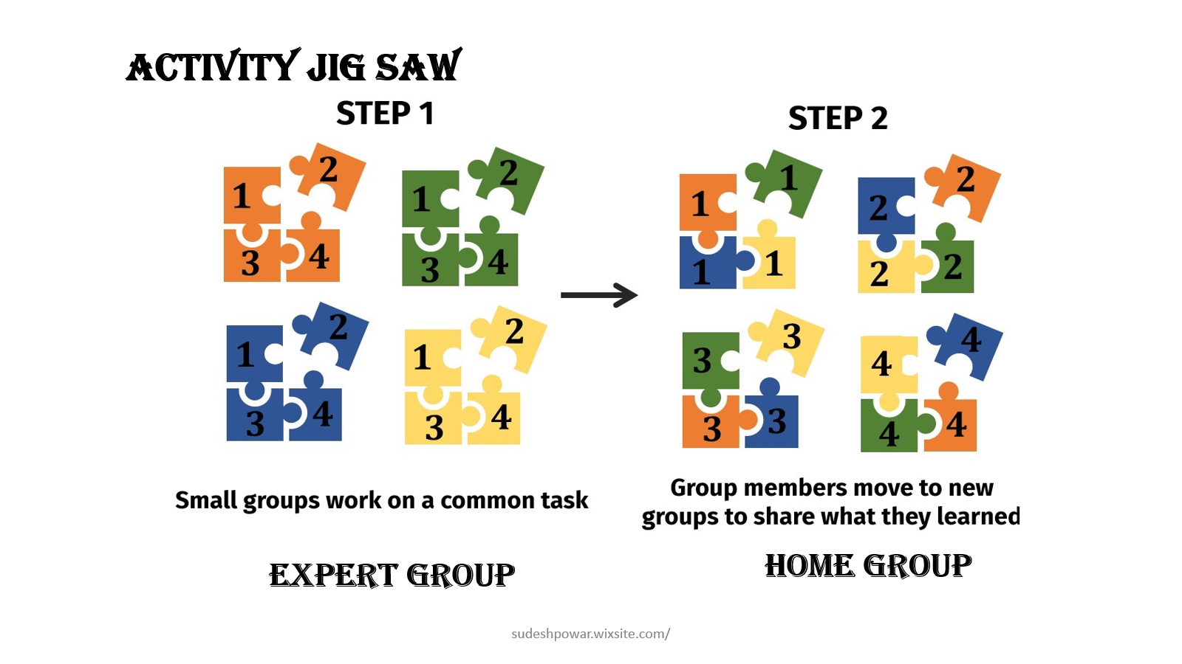  Creating home groups among the students  Randomly home group is created with equal number(six) of students. To avoid the confusion among the group and to make this activity enjoyable I assigned group name like H1, H2, H3, H4, H5, H6 after this assigned content to each member of the home group.  Forming expert group  The students who are having same content formed another group as expert group(location will change). Time (40 min) allotted to these group to read and understand the concept. During this time student used internet, books, notes or any material related to the concept.  Return to home group  When the given time was over student returned to their home group. Each student was having some information which he shared to the remaining members.

MCQ test (10 min)
A question paper containing 10 MCQs provided to each student. Student has to solve them individually.
Drive link of activity record
Peer review & critique

Course Name / Class / Year | Fluid Mechanics/SYBTech/2020-21
Faculty members involved | Mr. Sudesh Powar
Pedagogical Methods | Asynchronous Learning
Description of the activity | - Website and youtube channel developed for asynchronous learning

Drive link of activity record | https://sudeshpowar.wixsite.com/home/fluid-mechanics and https://www.youtube.com/watch?v=B7_hIZIp-7s&t=6s  Reynold's Experiment to identify the type of flow
Peer review & critique

Course Name / Class / Year
Faculty members involved
Pedagogical Methods
Description of the activity

Drive link of activity record
Peer review & critique

Drive link of activity record
Peer review & critique

Course Name / Class / Year
Faculty members involved
Pedagogical Methods | Method:  Topic Presentation on applications of Energy harvesting  Description:  - a  - b  - c  Benefit to Students:  - a  - b  - c
Description of the activity

Drive link of activity record
Peer review & critique

Course Name / Class / Year
Faculty members involved
Pedagogical Methods | Method:  Description:
Description of the activity

Drive link of activity record
Peer review & critique

